MTSO Cross-Cultural Immersion:
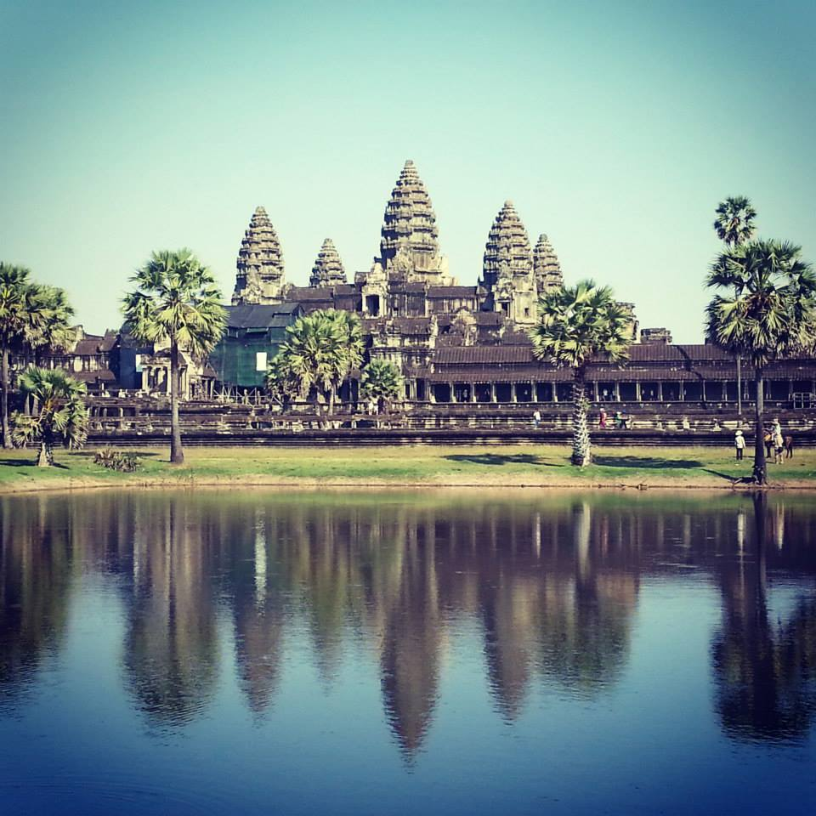
Cambodia
and
Vietnam
Ankor wat

Led by Dr. Joon-Sik Park (jpark@mtso.edu)

January 2018

Objectives of the Trip:
- To be introduced to the histories, cultures and religions, as well as political and socioeconomic issues, of Cambodia and Vietnam.
- To study the implications and challenges of globalization for both the human community and the church.
- To explore and experience the nature and dynamics of intercultural communication and to develop intercultural sensitivity in the context of cross-cultural encounter.
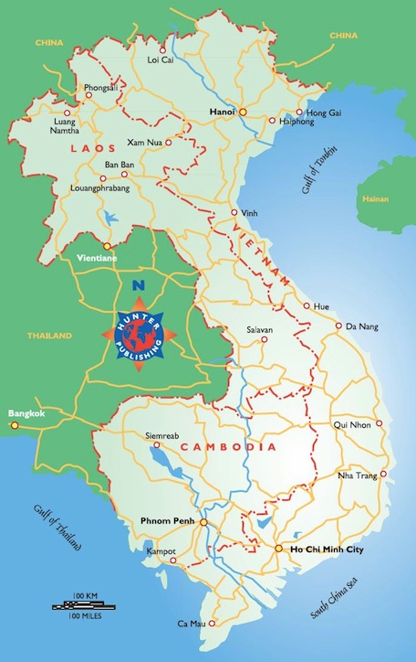
Places to Visit:
- In Cambodia
- Killing Fields and Genocide Museum
- Angkor Wat
- Center for Khmer Studies
- United Methodist Mission Center and Cambodia Methodist College
- International Justice Mission
- In Vietnam
- Cultural, Historic and Religious Sites (e.g., Ho Chi Minh Mausoleum and Hoa Lo Prison)
- Vietnam-USA Society and Friendship Village in Hanoi
- Government Committee of Religious Affairs and Ministry of Foreign Affairs
- Hagar International (a ministry with human trafficking victims)
- Visit with Christian Leaders

Estimated Cost: $3,500. MTSO collects $3,000 per student toward the cross-cultural trip; students will need to come up with additional funds for the trip.

Enrollment limit: 14

